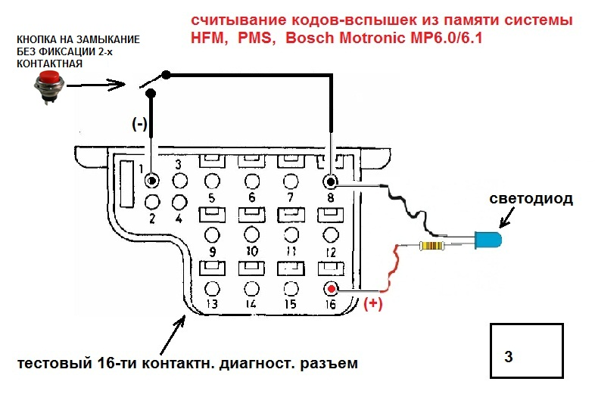Резистор 1КОм

1. 1 No fault found
2. 2 Engine Coolant temperature sensor
3. 3 Intake air temperature sensor
4. 4 Hot film mass air flow sensor
5. 5 CTP switch
6. 6 Not used
7. 7 Not used
8. 8 Idle speed control (ISC) system at upper or lower control stop or CC or EA indicates "limp home" mode.
9. 9 O2S 1 (before TWC) - voltage too high, circuit open or voltage implausible
10. 10 O2S 2 (after TWC)voltage too high, circuit open or voltage implausible
11. 11 O2S 1 heater (before TWC) - Current too high/low or short circuit.
12. 12 O2S 2 heater (after TWC) - Current too high/low or short circuit.
13. 13 O2S (Lambda) control system operating at rich or lean limit
14. 14 Injector, cylinder 1
15. 15 Injector, cylinder 2
16. 16 Injector, cylinder 3
17. 17 Injector, cylinder 4
18. 18 Injector, cylinder 5
19. 19 Injector, cylinder 6
20. 20 Self-adaptation at idle speed or upper/lower partial load at rich or lean limit
21. 21 Ignition output 3 or ignition coil for cylinder 1 and 6
22. 22 Ignition output 1 or ignition coil for cylinder 2 and 5 (Engine 111, cylinder 1 and 4)
23. 23 Ignition output 2 or ignition coil for cylinder 3 and 4 (Engine 111, cylinder 2 and 3)
24. 24 CKP sensor or magnet for position sensor not recognized
25. 25 CMP sensor not recognized or implausible
26. 26 Not used
27. 27 TN-signal (rpm signal ) - open or short to ground
28. 28 VSS - open circuit
29. 29 Not used
30. 30 Fuel pump relay module - open or short circuit
31. 31 Not used
32. 32 Knock sensors 1 and /or 2
33. 33 Maximum retard setting on at least one cylinder has been reached or the ignition angle deviation between the individual cylinders is greater than 6 degrees crankshaft angle
34. 34 Knock control-output switch in engine control module faulty Momentary fault in self-adaptation closed throttle speed/partial load
35. 35 Model 124,129 and 140 AIR pump switchover valve and/or electromagnetic AIR pump clutch. Model 202 AIR pump switchover valve and/or AIR relay module
36. 36 Purge control valve - open/short to ground or B+
37. 37 Transmission Upshift delay switchover valve (Y3/3) without function (Logic Chain) - Check vacuum and adjust Bowden cable.
38. 38 Adjustable camshaft timing solenoid - open/short to ground or B+
39. 39 Exhaust gas recirculation switchover valve - open/short to ground or B+
40. 40 Transmission overload protection switch - open/short to ground or B+ or open or closed or implausible
41. 41 CAN communication from engine control module faulty
42. 42 CAN communication from ASR, EA/CC/ISC module or diagnostic
43. 43 Starter signal (circuit 50) not present
44. 44 Not used
45. 45 Fuel safety shut-off of electronic accelerator or cruise control
46. 46 Resonance intake manifold switchover valve - open/short to
47. 47 Not used
48. 48 O2S 2 (after TWC) heating circuit relay module - open/short
49. 49 Voltage supply at engine control module implausible/low volts.
50. 50 Engine control module faulty or not coded.